# *Instructor Prep-sheet:*

# **Leveraging Generative AI for UX Designers (Demo)**

## **TL;DR:**

This prep-sheet is designed to give you an idea of how to conduct your live ChatGPT demonstration. A few things to remember:

1. Do a dry run of your demo before you are live and in front of students
2. Be prepared for slight variance in ChatGPT’s outputs each time you do the demo
3. Highlight the impressive capabilities of ChatGPT, along with its limitations!

* *If you end up with a demo that was particularly interesting, please share the link* [*here*](https://docs.google.com/spreadsheets/d/1eWa3s_gkPYEfLKoBXG-83LErmMJ60elgCjuePFlPo4Y/edit#gid=0) *along with a short description!*

## **Sample Materials:**

* [Sample Demo Recording](https://www.loom.com/share/638276a992ed48649852f0dead4c7f73?sid=b4251c34-ffff-4068-9393-96a57544c6c3)
* [Sample ChatGPT Thread](https://chat.openai.com/share/972e577e-a616-4a46-be40-00f2b31869ad)

## **Preparation:**

* Review the sample demo and ChatGPT thread in ***detail:***
  + This is an example of how you can structure the demo.
  + You may want to structure your demo to fit more closely to the research parameters of the student’s practice activity
  + At the end of the day this is your demo - take it in whatever direction you find most impactful based on your students and teaching style
* Login to [ChatGPT](https://chat.openai.com/) (you will just use the free version for this demo)

## **Instructor Demo Sample:**

* *The video below is a live recording of* [*this sample ChatGPT thread*](https://chat.openai.com/share/972e577e-a616-4a46-be40-00f2b31869ad) *in which a user asks ChatGPT to help them create a user survey.*
* *If you decide to come up with your own demo, be sure to highlight the impressive capabilities of the tool, as well as the limitations.*
* *It is also important to make clear the need for the user to be a skilled UX Designer in order to get the most out of the tool - ChatGPT is not a replacement for a good designer!*

[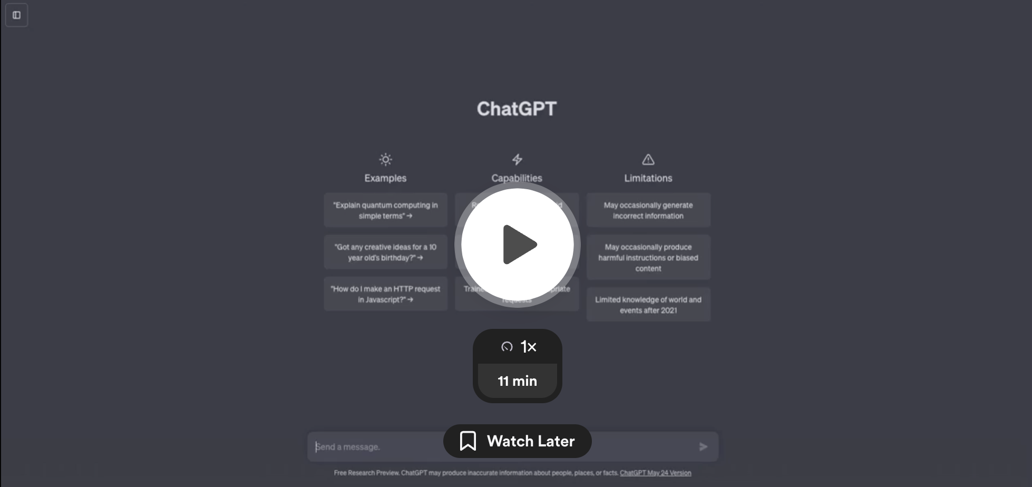](https://www.loom.com/share/638276a992ed48649852f0dead4c7f73?sid=0845cd06-2374-47d6-921a-0531fe484704)